Object Oriented Programming with Java
Assignment on JSP and JDBC

Insurance Management System

Submitted By:
Name: Raghavendra
Roll No: 24B-IT-045
Batch: C
Authentication page:
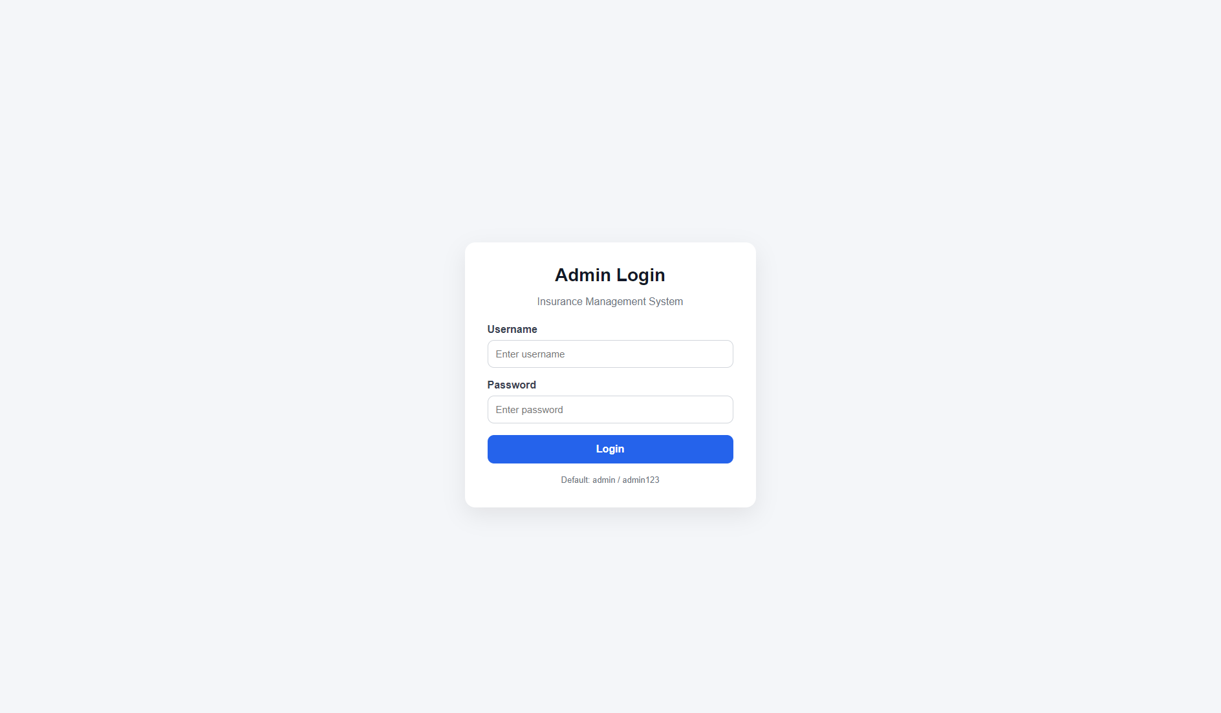

Dashboard page:
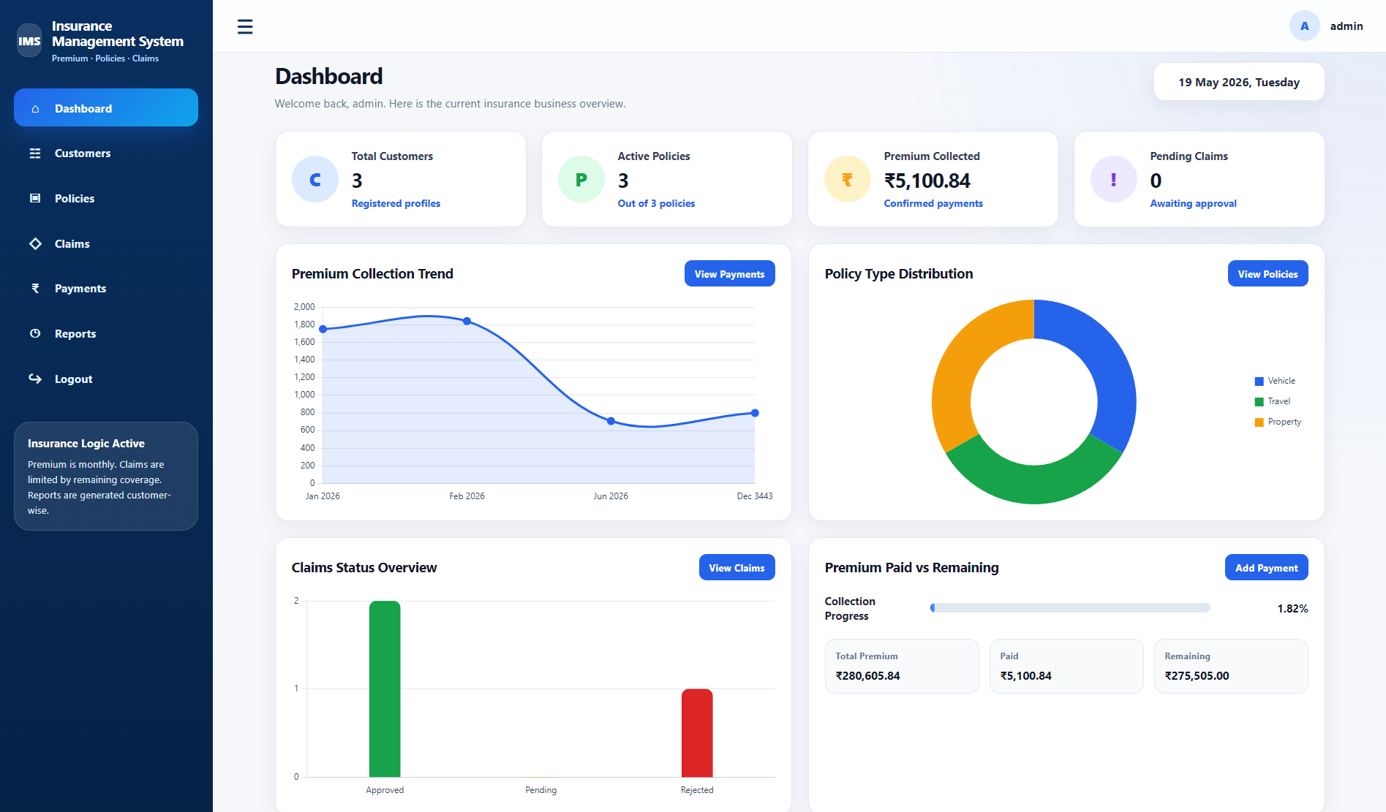
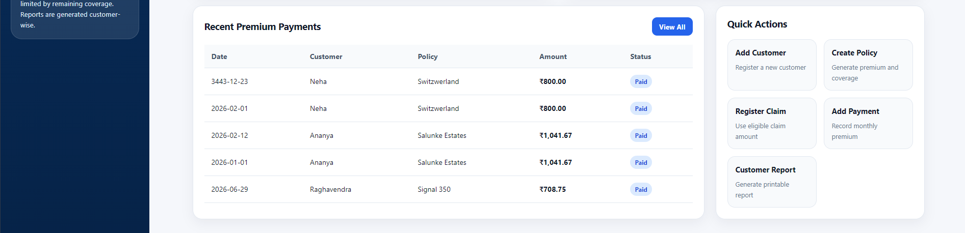
Customer Management page:
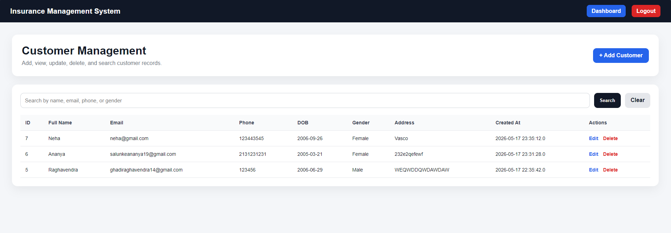

Policy Management page:
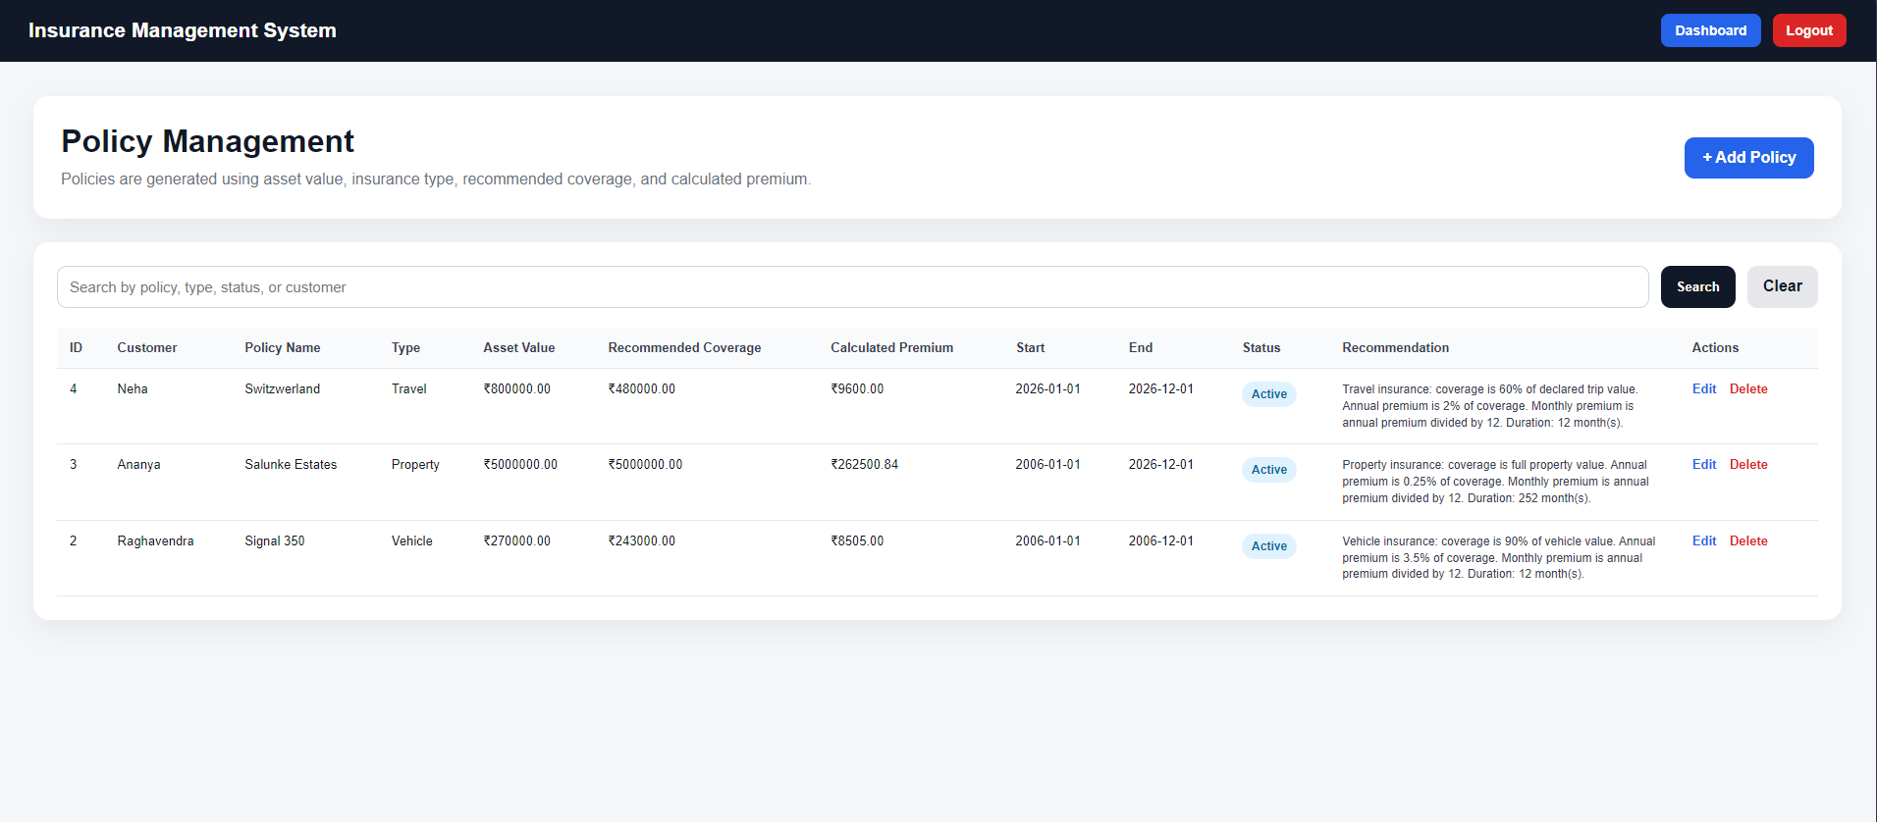

Claim Management page:
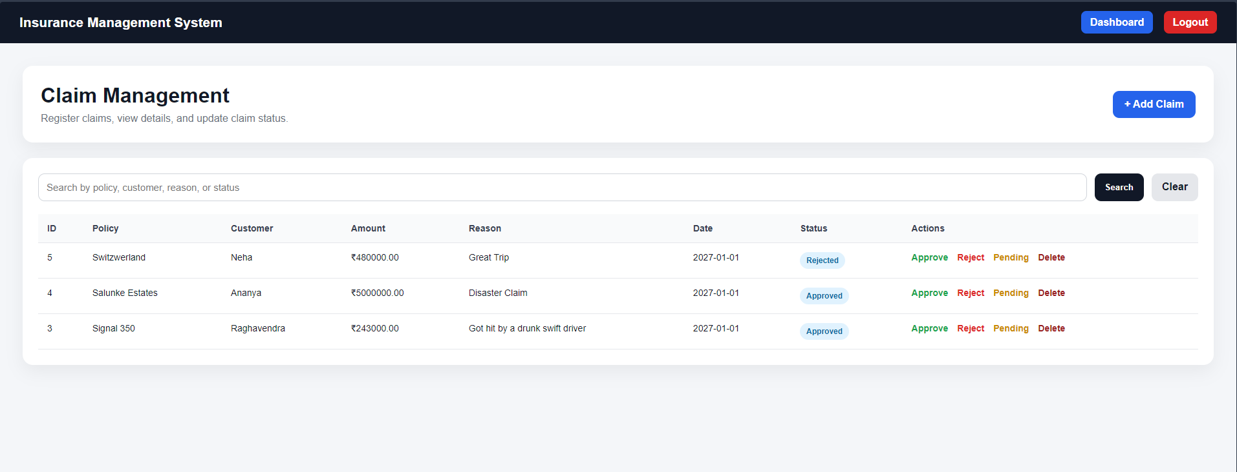

Payment Management page:
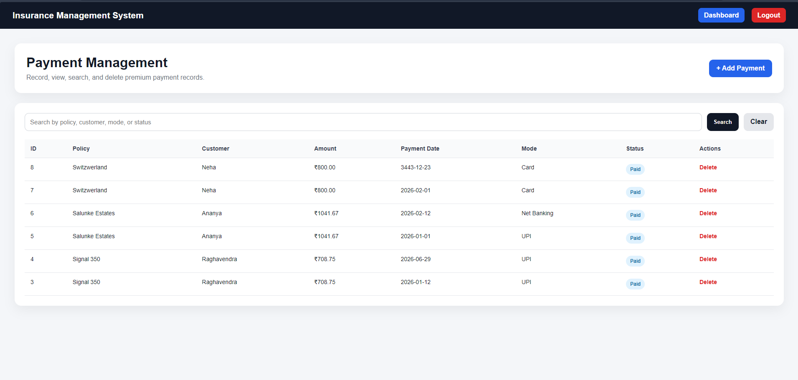

Customer Insurance Report:
